**Report of A Health Awareness Camp Under “Goal of End TB By 2025” Program of Ministry of Health and Family Welfare, Government of India, organized by GGV, Bilaspur**

**Date of Event : January 11, 2023**

**Venue :** Hall No 1, Rajat Jayanti Sabhagar**, Guru Ghasidas Vishwavidyalaya, Bilaspur, Chhattisgarh.**

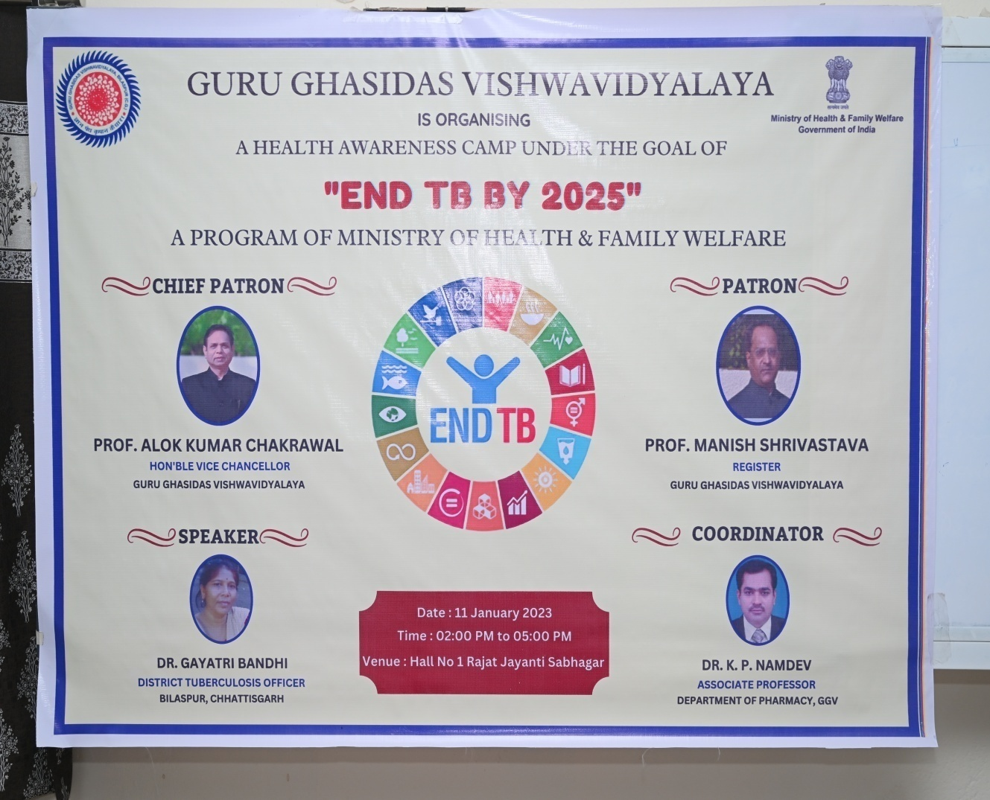

**<Flyer of A Health Awareness Camp Under the Goal of “End TB by 2025”>**

**Details of Event Proceedings**

|  |  |  |  |
| --- | --- | --- | --- |
| Date  (DD-MM-YYYY) | Details of the Session | Details of Resource Person | Number of Participants |
| 11-01-2023 | **2022-2023** | **Dr. Gayatri Bandhi, District TB Officer Bilaspur (CG)** | **125** |

***A Brief Abstract of the Event (Maximum 400 words)***

The Ministry of Health and Family Welfare under the counsel of the Hon’ble Prime Minister has extended efforts to end the spread of TB by 2025. Combined efforts from the ministries and the educational institutes over the country shall help in the timely diagnosis and treatment of TB and thus achieve the goals set by the ministry. Conduction of awareness programs shall reduce the stigma associated with the diagnosis, prevention, treatment and social protection for TB infected patients.

Guru Ghasidas Vishwavidyalaya, Bilaspur organized one day health awareness camp on **Goal of End TB-2025** programme under the Ministry of Health and Family Welfare, Govt of India for Universities students and staff. **Dr. Gayatri Bandhi,** District TB Officer Bilaspur (CG) had given her valuable time for this programme, which was organized on **11.01.2023 from 2.0 PM to 5.0 PM.** The key note speaker shared her experience and knowledge with the participants about awareness generation, infection control, prevention, care and treatment of TB. The following distinguished persons attended the programme;

1. ***Prof. Alok Kumar Chakrawal*** [Hon’ble Vice Chancellor, GGV, Bilaspur]
2. ***Prof. Manish Srivastava*** [Hon’ble Registrar, GGV, Bilaspur]
3. ***Prof. P. K. Bajpai*** [Director IQAC, GGV, Bilaspur]
4. ***Prof. V.D. Rangari*** [Professor, Dept of Pharmacy, GGV, Bilaspur]

During this programme, the Key speaker and Resource Person **Dr. Gayatri Bandhi,** District TB Officer Bilaspur (CG) interacted with the participants and shared her knowledge for prevention and spread of Tuberculosis. The participants also asked their queries regarding the topic and preventive care of TB. The participants included the students from the D. Pharm, B. Pharm M. Pharm, PhD Courses, Faculty Members and Staff Members. The anchoring of the programme was done by Dr. Vivekanand Mandal, Assistant Professor, Dept of Pharmacy and vote of thanks given by Professor Alpana Ram. The main aim of this programme was to provide preventive care, awareness generation, infection control and treatment of TB to the participants, University teachers, staff and the students. The participants came to know about the basic concepts of preventive care for spread of TB. ***Prof. Alok Kumar Chakrawal***, Honourable Vice Chancellor of GGV, Bilaspur always encourages conducting these kinds of activities in different teaching departments. We extend warms thanks to Hon’ble VC Sir, Hon’ble Registrar Sir and administration of GGV for their support and motivation.

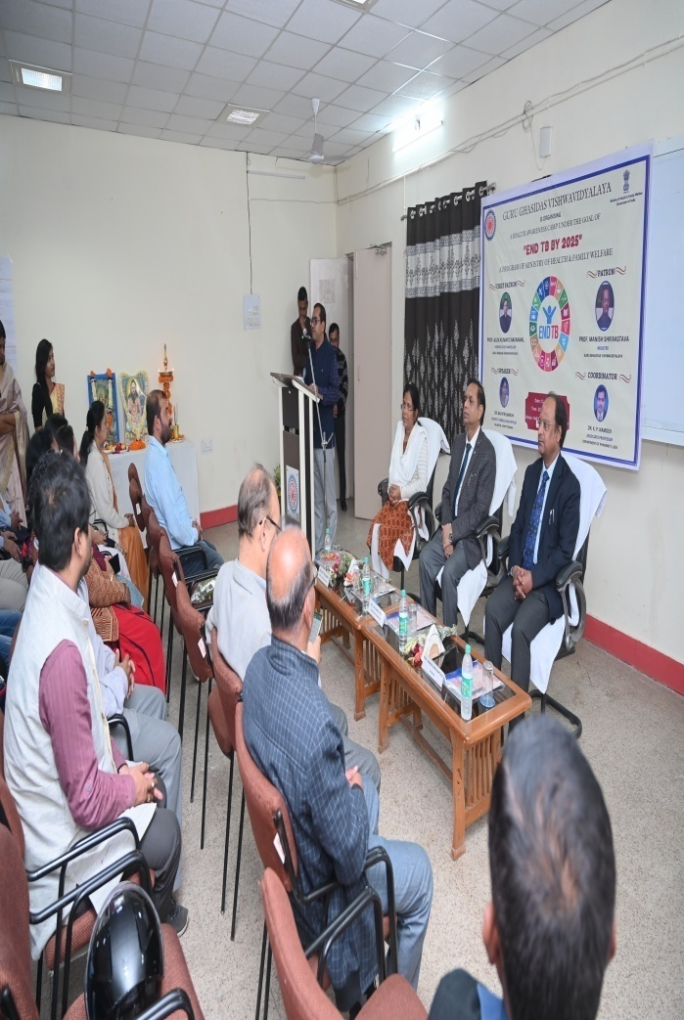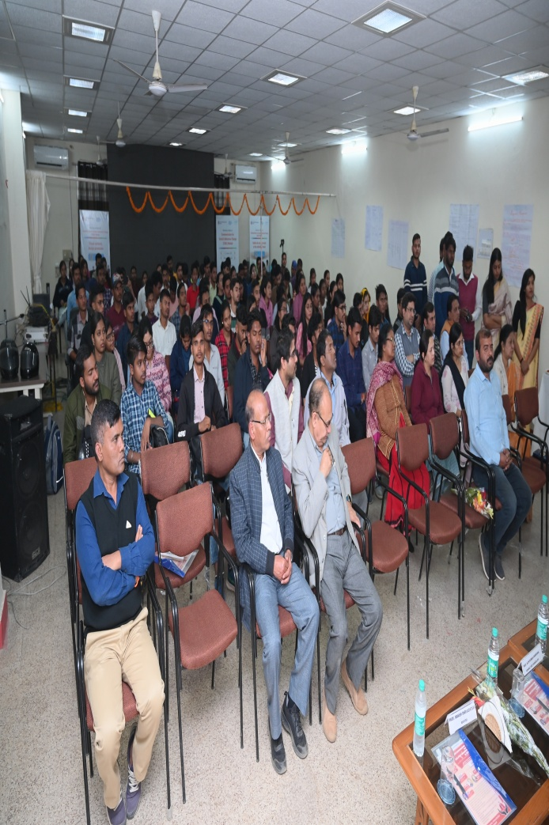

**< A Health Awareness Camp under the Goal of “End TB by 2025” with the Participants and Distinguished Guests >**

**Signature**

**Coordinator**

**Goal of END TB by 2025**

