**A Report on National Workshop**

**on theme**

**Development of Advanced Drug Delivery Systems**

**……………………………………………………………………………………………………….**

**Date of Event : March 22, 2024**

**Venue : E-classroom of Department of Pharmacy**

**Details of Events Proceedings**

|  |  |  |
| --- | --- | --- |
| **Date** | **Details of Resource person** | **Number of Participants** |
| 22/3/2024 | Prof Khemchand Dewangan | 166 |

Department of Pharmacy and Technology Enabling Centre (TEC), Guru Ghasidas Vishwavidyalaya, Bilaspur (CG) jointly organized a National Workshop on theme “Development of Advanced Drug Delivery Systems” on March 22, 2024.

This pioneering event brought together experts, researchers, academicians, and students to delve into the latest advancements and innovations in drug delivery technologies. The workshop aimed to foster collaboration, share knowledge, and discuss the future direction of drug delivery systems in improving patient care.

The programme began with the inauguration of the National Workshop at 10:30 am at the e-classroom of Department of Pharmacy. Dean - School of Natural Resources – Prof. S.C. Tiwari, HOD - Prof. Bharti Ahirwar, Convener Dr. Harish Rajak and Co-convener Dr K Kesavan were present on the dais for the inaugural ceremony. The workshop received an overwhelming response and 166 participants were registered for the workshop out of which 55 participants were outside GGV. The convener of workshop Dr. Harish Rajak detailed out about workshop and emphasised the need for training young generation and producing skilled manpower as the main motto behind organizing this workshop. Professor Bharti Ahirwar welcomed all the guests and highlighted the need for developing skills which can play a pivotal role in research and innovation. Dean Prof. S.C. Tiwari motivated the students and participants to accept new challenges and perform to their fullest potential. He also emphasized the need to translate laboratory research into commercially viable products for the benefit of the society.

HoD Prof. Bharti Ahirwar and Dean Prof. S.C. Tiwari expressed their gratitude towards Honourable Vice-Chancellor Prof Alok Kumar Chakrawal for providing constant encouragement and for the ongoing holistic development of the University. Dr Harish Rajak, Conver of the workshop expressed the thankfulness to Prof. Alok Kumar Singh Kushwaha, Co-ordinator, Technology Enabling Centre (TEC), Guru Ghasidas Vishwavidyalaya, Bilaspur (CG) for planning and financial assistance of the workshop.

The speaker Prof Khemchand Dewangan, Department of Chemistry, Guru Ghasidas Vishwavidyalaya, Bilaspur delivered a talk on “Application of Biomaterials in Drug Delivery”. He discussed different possibilities in the field of advanced drug delivery systems.

The participants were divided in multiple batches comprising of 15 students in each batch. The students were given a Hands-on training session regarding the development of advanced drug delivery systems especially nanoparticles and their characterization using FT-IR and Fluorescence spectroscopy. Data acquisition and interpretation of results were also vividly explained and demonstrated.

At the end of the workshop, certificates were provided to the participants. Department of Pharmacy expressed thankfulness to Technology Enabling Centre (TEC), Guru Ghasidas Vishwavidyalaya, Bilaspur (CG) for providing financial support to organize this national workshop.

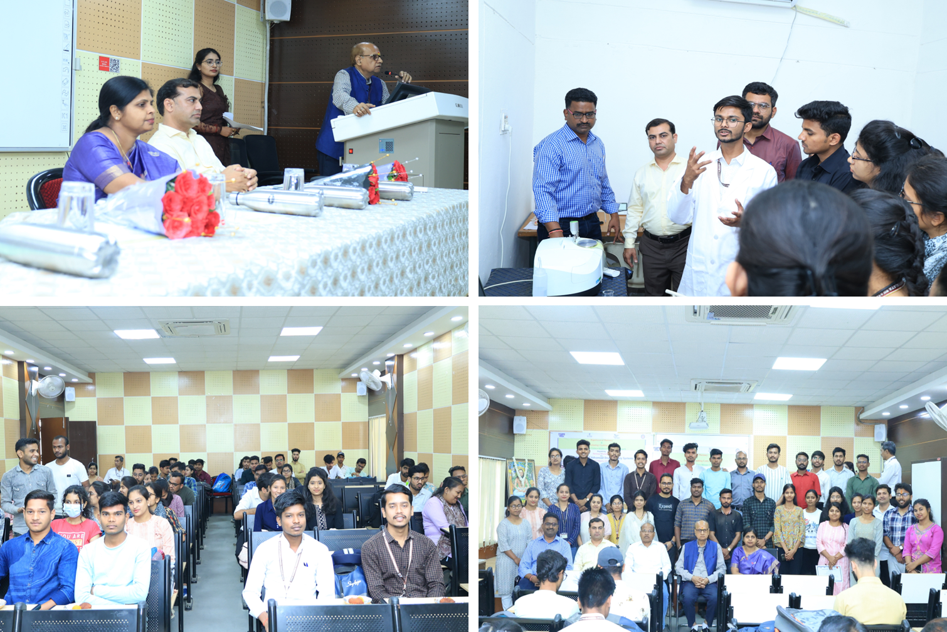

**Photographs of National Workshop on theme “Development of Advanced Drug Delivery Systems” on March 22, 2024**