**Report of A Health Awareness Rally Under “Goal of End TB By 2025” Program of Ministry of Health and Family Welfare, Government of India, organized by GGV, Bilaspur**

**Date of Event : March 24, 2023**

**Venue : From Department of Pharmacy to Guru Ghasidas statue, Guru Ghasidas Vishwavidyalaya, Bilaspur, Chhattisgarh.**

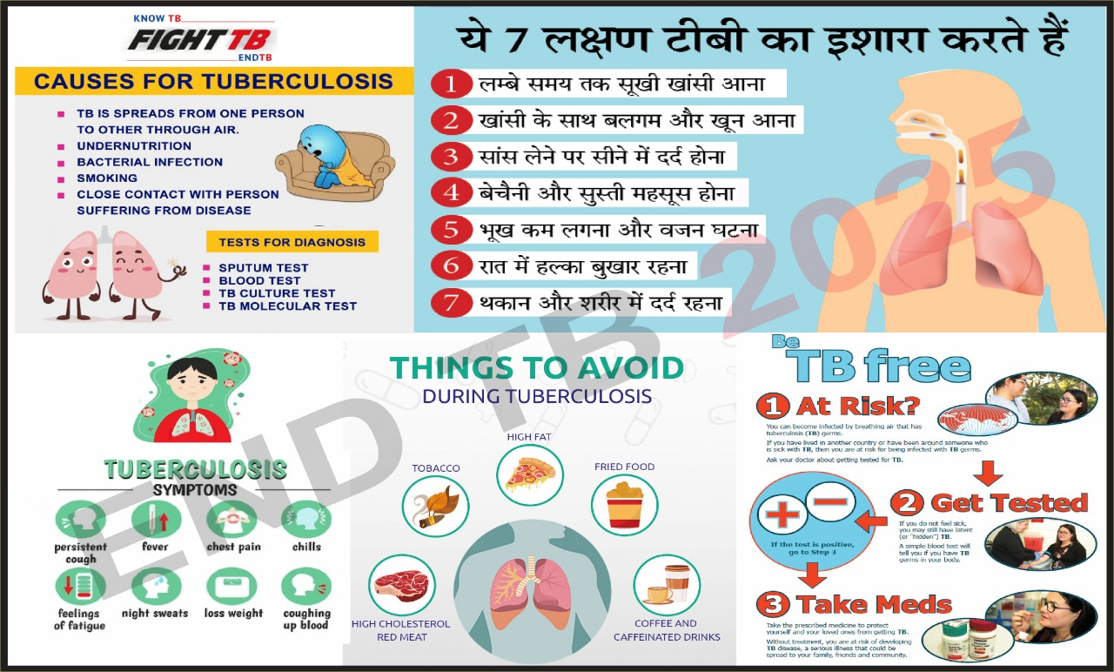

**<Flyer of Rally on “Under “Goal of End TB By 2025”>**

**Details of Event Proceedings**

|  |  |  |  |
| --- | --- | --- | --- |
| Date  (DD-MM-YYYY) | Details of the Session | Details of Resource Person | Number of Participants |
| 24-03-2023 | **2022-2023** | **Dr. S. C. Tiwari Dean, School Of Natural Resources Bilaspur (CG)** | **95** |

***A Brief Abstract of the Event (Maximum 400 words)***

The Ministry of Health and Family Welfare under the counsel of the Hon’ble Prime Minister has extended efforts to end the spread of TB by 2025. Combined efforts from the ministries and the educational institutes over the country shall help in the timely diagnosis and treatment of TB and thus achieve the goals set by the ministry. Conduction of awareness programs shall reduce the stigma associated with the diagnosis, prevention, treatment and social protection for TB infected patients.

Guru Ghasidas Vishwavidyalaya, Bilaspur organized a health awareness rally **on the occasion of world TB Day under Goal of End TB -2025,** programme under the Ministry of Health and Family Welfare, Govt of India for Universities students and staff. **Professor S.C.Tiwari Dean School of Natural resources GGV** Bilaspur (CG) had given his valuable time for flagging off the rally, which started at 11.30AM on 24**.03.2023.** The theme of rally was “Han Ham TB ko khatm kar sakte hai” and awareness generation, infection control, prevention, care and treatment of TB. The Teachers, students and staff of Department of Pharmacy and Department of forensic sciences joined the programme;

During this programme, the rally passed through different departments, administrative building to Param Pujya Guru Ghasidas Babaji statue with different slogan for control and prevention of spread of Tuberculosis like: - 1. Yog aur dhyan apnana hai TB door bhagana hai, 2. Jan Jan ka ho ek hi nara, TB Mukt ho desh hamara, 3.TB se ladna hai , hame swashthya rahna hai. The students from the D.Pharm B. Pharm M. Pharm, PhD Courses, Faculty Members and Staff Members participated in the rally. We extend warms thanks to Hon’ble VC Sir, Hon’ble Registrar Sir and administration of GGV for their support and motivation.

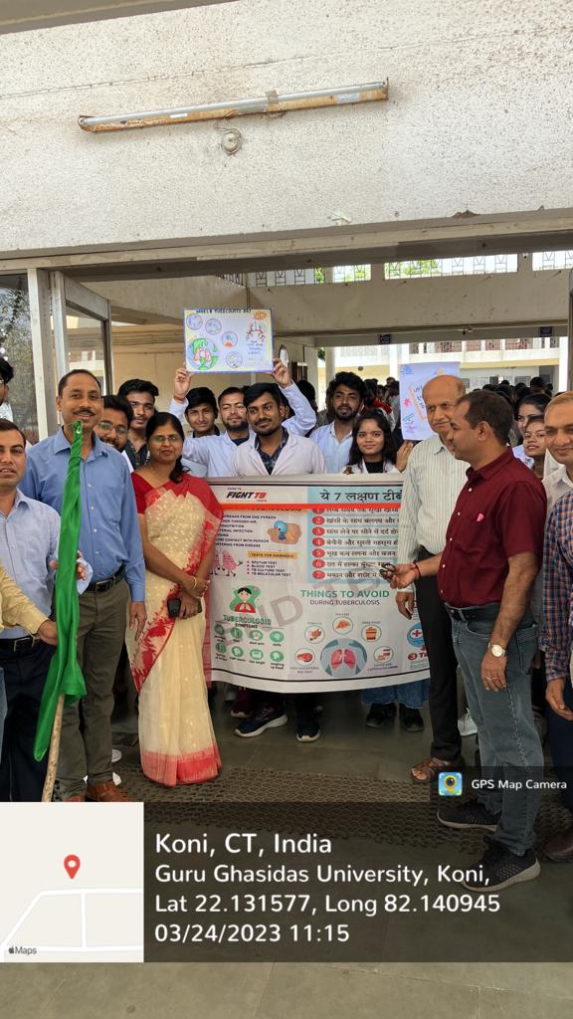

**<Rally flagging off by Dean School of Natural resources and Head Department of Pharmacy with the Participants and Teachers >**

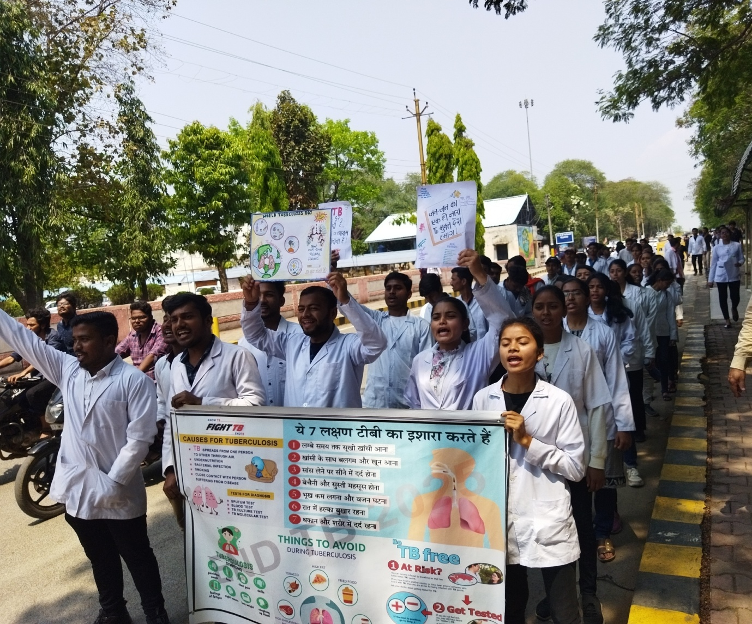

**<Rally Passed through Administrative Office, GGV >**

**Signature**

**Co-ordinator**

**Goal of END TB by 2025**

