**REPORT OF THE PROGRAM**

On March 1, 2024, at 6:00 PM, an Invited talk on Industry-Academia Collaboration was held at the Department of Commerce, Guru Ghasidas Vishwavidyalaya, Bilaspur (C.G.) for its faculty members and the faculty members of the department of Management. Dr. G. S. Rao, Managing Director of Sravan Shipping Services Pvt. Ltd., Visakhapatnam, served as the main resource person for the event.

The program commenced with the welcoming of the guest and an brief introduction of him was read by HoD Commerce. After which Dr. G. S. Rao shared his valuable insights regarding his corporate experience and the inculcation of industrial approach and the university curriculum and how students could be involved in such collaboration programs. The session concluded with the vote of thanks conveyed by the HoD Commerce Prof. Bhuvana Venkatraman.

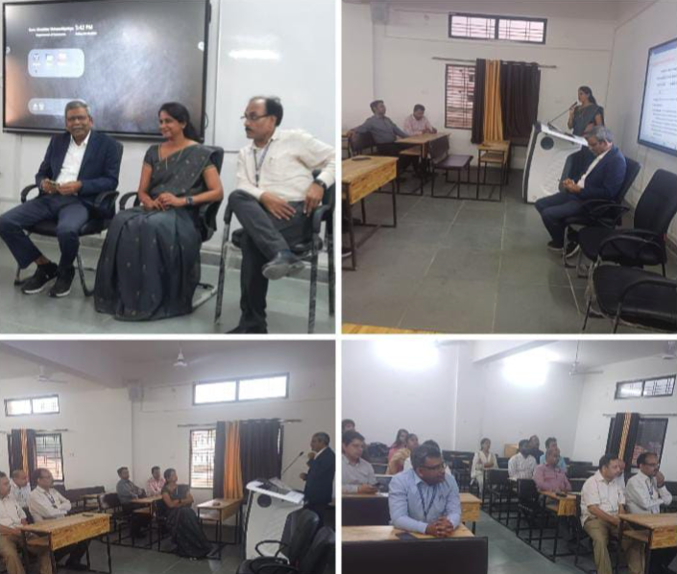Top of Form