***CURRICULUM VITAE***



**PERMANENT ADDRESS**

**S/o Shri. V.D. Sharma**

**22/A, Arjun Nagar,**

**(Balwant Nagar),**

**Gandhi Road,**

**Gwalior, Pin 474002**

**Madhya Pradesh, INDIA**

**PERSONAL INFORMATION:**

**Name:**  Dr. **JITENDRA SHARMA**

**Father’s Name: Shri. V.D. Sharma**

**Date of Birth:**  **January 27, 1976**

**Nationality: Indian**

**Marital Status: Married**

**Gender: Male**

**Passport Number: N8063359**

**E-Mail:** [**jitendra_sharma27@yahoo.co.in**](mailto:jitendra_sharma27@yahoo.co.in)

**Mobile Number: 7042108434, 9971428933**

**Phone Number: +917512340462**

**ACADEMIC QUALIFICATION:**

* **Secondary Examination from C.B.S.E. Board, New Delhi in the year 1991.**
* **Senior Secondary Examination from C.B.S.E. Board, New Delhi in the year 1993.**
* **B.P.E. (Bachelor Degree in Physical Education) from L.N.I.P.E., Gwalior in the year 1998 ( Yoga ).**
* **M.P.E. (Master Degree in Physical Education) from Jiwaji University, Gwalior (India) in the year 2000 ( Athletics).**
* **M.Phil. (Master of Philosophy in Exercise physiology in Physical Education) from L.N.I.P.E., Gwalior in the year 2003( Footballand Hockey comparative study).**
* **6 months certificate course in Fitness training and conditioning from**

**Department of sports science, Rajiv Gandhi University,Arunachal Pradesh .**

* **Phdin exercise physiology(comparative**

**Studyin yogaand Fitness among M.P state level college players) from satyasai**

**University of technology and medical science,sehore,Bhopal,M.P 2022.**

* **Health Club Manager Certification from American Sports and Fitness Association.**

**SPECIALIZATION:**

**Practical**

* **Yoga (B.P.E.).**
* **Track and Field (M.P.E.).**
* **Football and Hockey (M.Phil.).**

**Theoretical**

* **Exercise physiology (M.Phil.).**
* **Sports medicine in physical education.**
* **Research methods in physical education.**
* **Corrective in physical education, treatment prevention, and care of athletic injuries.**
* **Management of physical education and recreation.**
* **Health education, test, and measurements.**
* **Advanced statistics and computer applications.**
* **Fitness training and conditioning methods.**

**ADVANCED GROUP:**

* **Hockey**
* **Yoga**
* **Athletics**
* **Football.**
* **swimming**
* **Table tennis**
* **badminton**

**AREA OF INTEREST:**

* **Aerobics.**
* **Skiing.**
* **Hockey.**
* **Football.**
* **Cricket.**
* **Swimming.**
* **Develops fitness programs for different games and palygrounds.**
* **Expert in fitness assessment on B.S.D.I ( specialization basic for assets the player**

**And provide according , skill development and fitness for specific games and sports)**

**Essentials for basic , advance and international level , U.S.A software for fitness battery , test and measurement. (scientific 100./.result oriented).**

**SPORTS ACHIEVEMENTS:**

* **Represented Madhya bharat hockey team which participated in senior national games in Jammu and Kashmir in 2000**
* **Represented L.N.I.P.E., Hockey Team Gwalior (India), which participated in West Zone Inter-University Hockey Championship held at M.S. University, Baroda for the year 1997-98.**
* **Represented Gwalior District in the XXXIV M.P. State Basketball Championship for the year 1995 held at Gwalior (India).**
* **Represented Jiwaji University Hockey Team Gwalior (India), which participated in All India Inter-university Hockey Championship, which held at Agriculture University Ludhiana for the year 1999-2000.**
* **Represented Jiwaji University Hockey Team Gwalior, which participated in West Zone Inter-University Hockey Championship and secured First Position held at J.N. Vyas University Jodhpur for the year 1999-2000.**
* **Represented Jiwaji University Athletics Team Gwalior, which participated in All India Inter-versity Athletics Meet, which held at M.S. University Thirunelveli for the year 1998-1999.**
* **Represented Jiwaji University in the M.P. State Athlete Meet for the year 1998-1999 held at Bhopal and secured First Position.**
* **Represented L.N.I.P.E. Gwalior in Indian Skiing Adventure Championship held at Narkanda, Himachal Pradesh for the year 2002.**
* **Participated in National Championship in Sports Dance and Fitness (Aerobics) held at Lakshmibai National Institute of Physical Education, Gwalior in the year 2000 organized by American Aerobics Association.**
* **Represented Jiwaji University in the M.P. State Hockey Championship for the year 1998 held at Neemach and secured First Position.**
* **Represented S.O.S., Jiwaji University in the Inter-college football championship and secured second position for the year 1998-1999.**
* **Participated in 55th STAG M.P. State and inter district table tennis championship - 2012**
* **3rd M.P. State ranking T.T. Tournament 2012 under M.P.T.T. Association Indore,organised by distt T.T. Association Khandwa- secured 3rd place in Men's Single**

**PROFESSIONAL EXPERIENCE:**

* **Officiated in All India Inter-university Athletics Championship Meet in the year 1996-1997 and 1999-2000.**
* **Officiated in All India C.B.S.E. School Athletics Championship Meet in the year 1997-1998.**
* **Officiated in the M.P. State open Basketball Championship in the year 1995 and in the West Zone Inter-University in the year 2001.**
* **Officiated in the State Level Athletics Meet organized by J.N.K.V. Vidyalaya Agriculture University Jabalpur held at Gwalior in the year 1999.**
* **Worked as Physical Education teacher in Kiddys Corner Higher Secondary School Gwalior in the year 2000-2001.**
* **Organized Annual Sports day of KhusalVidhyapeeth, Gwalior Glory Higher Secondary School and Kiddys Corner in the year 1999-2001.**
* **Worked as a Teacher Assistant and took B.P.E. 1st year class of Hockey in the L.N.I.P.E. Gwalior as an essential part of education for the year 2002-2003 in Master of Philosophy.**
* **Worked as a part time Football coach in the Scindia School Fort on the part time basis for the year 2002**
* **Worked as a Hockey coach in K.R.G. Gov. P.G. College on part time basis for the year 2001-2002.**
* **Worked as a Swimming coach cum lifeguard in the Hotel Regency, Gwalior on part time basis for the year 2002.**
* **Worked as a Sport Trainer/Fitness Instructor in U.A.E. Army forces under Al-Qudra sports management ABUDHABI ,U.A.E in Dubai for the years 2004-2011.**
* **Worked as Manager& Exercise physiologist in Presidential Guard, U.A.E. armed forces in DUBAI , U.A.E since 2011-2012.**
* **Worked as Public Relation Director in Contingency Commercial Broking L.L.C., DUBAI, U.A.E for the year 2012-2013.**
* **Worked as Administrator in Madreqat, IT company DUBAI , U.A.E since 2013 -2016.**
* **Workedas Physical education teacher in Indian high school, Al seeb, MUSCAT, OMAN from 2016-2020.**
* **Played elementry role in Ambassador cup hockey championship 2017 and win the cup in boys and runner up in girls, for indian school Al-Seeb.**
* **Officiated Badminton inter house tournament 2017 at srilankan international school Muscat ,Oman**
* **Officiated Table Tennis inter house tournament 2017 at srilankan international school Muscat ,Oman**
* **winner of mens and womensindependencedayambassdors hockey cup , MUSCAT , OMAN, in jan 2018.**
* **Working as Assitant professor in department of physical education ,Jiwaji university,( NAAC-A++) Gwalior, M.P as Guest faculty.**
* **Working as sport officer as guest faculty in Madhav law college ,Gwalior, M.P.**

**EXTRACURRICULAR ACTIVITIES:**

* **Attended leadership training camp at Panchamadi organized by Lakshmibai National Institute of Physical Education Gwalior for the year 1995-1996.**
* **Attended NCC Annual Combined Training camp held at Gwalior organized by 08 M.P. B.n., NCC.**

**SCHOLARSHIP:**

* **Master of Philosophy in physical education from L.N.I.P.E., Gwalior.**

**RESEARCH STUDY:**

* **Comparison of anthropometric and psychological characteristics among All INDIA INTER UNIVERSITY Footballand Hockey goal keepers, (M.Phil.).**
* **Effect of yogic pr.atices on selected physiologicl and anthropometric variable among**

**College players, (Phd).**

.**INTERNATIONAL JOURNAL, RESEARCH PAPER PUBLICATION**: **IGNITED MINDS ( I A O) (GLOBAL EDUCATION MISSION) APPROVED BY U.G.C:**

* **The impact of physical activity and fitness on academic achievement and cognitive performance of children on 6-7-2011.**
* **Impact of nutrition and health in women, children and adolescent girls on 2-4-2012.**
* **Nutrition and health outcomes associated with food insecurity and hunger on 10-10-2012.**
* **Perceived exertion of physical activity : negative association with self-rated fitness on 5-4-2013.**
* **Effect of yogic practices on physical fitness with special reference to school children on10-10-2013.**
* **Assessment of the yoga on the status of the physical fitness among children on 6-1-2014.**
* **Athletes perceptions of sport and education : an in-depth analysis with reference to india on 7-4-2014.**
* **Study on physical education environment and sports facilities of college students on 4-1-2016.**
* **Analysis on hockey players : A study with reference to personality and injury risk on 5-1-2015.**
* **Study on athlete development (LTAD) encourages youth players to develop their athleticism through multiple sports. On 6-7-2015.**
* **The effect of extracurricular physical activity on bone properties, muscle strength on 12-7-2016.**

**NATIONAL CONFERENCE / SEMINAR :**

* **Health education and presented paper on fitness management for wellness. Organized by institute of professional studies , department of physical education (NAAC ‘A’ GRADE) 13-5-2014.**
* **Quality education through application of research and statistics in profession and presented research paper on health and hygiene for quality life on 31-5-2015.**
* **Innovations in physical education at national institute for career enhancement,safdarjung enclave , new delhi on 10-9-2013.**
* **Futuristic trends in physical education and sports held at royal institute technology, education and research, Ambala , Haryana.**
* **Research methodology : use of information technology in research methods held at vision institute of technology and management, Pune , Maharashtra. ( IMPARC).**

**. Ipmportance of inter-disciplinary studies in higher education in the areas of engi-**

**Neering,sc**

**BOOK PUBLISHED:**

* Exercise physiology , Health , Fitness and Performance.aaaaaaaaaaaa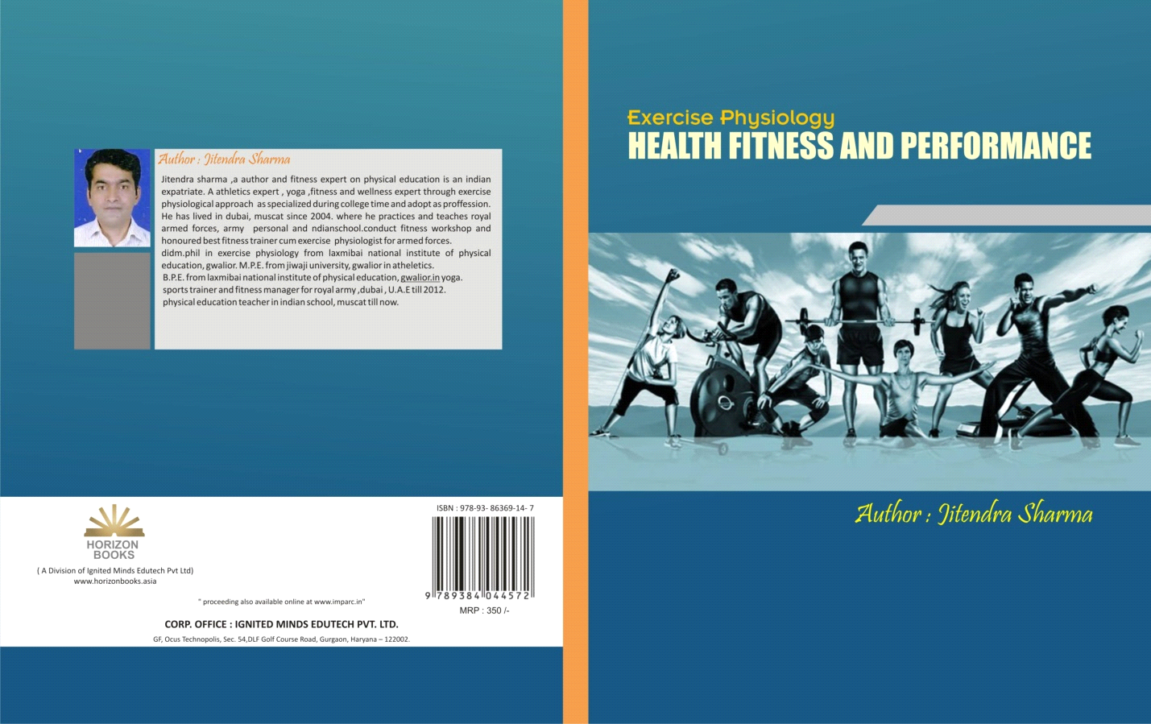
* Yoga Impact on Human Health.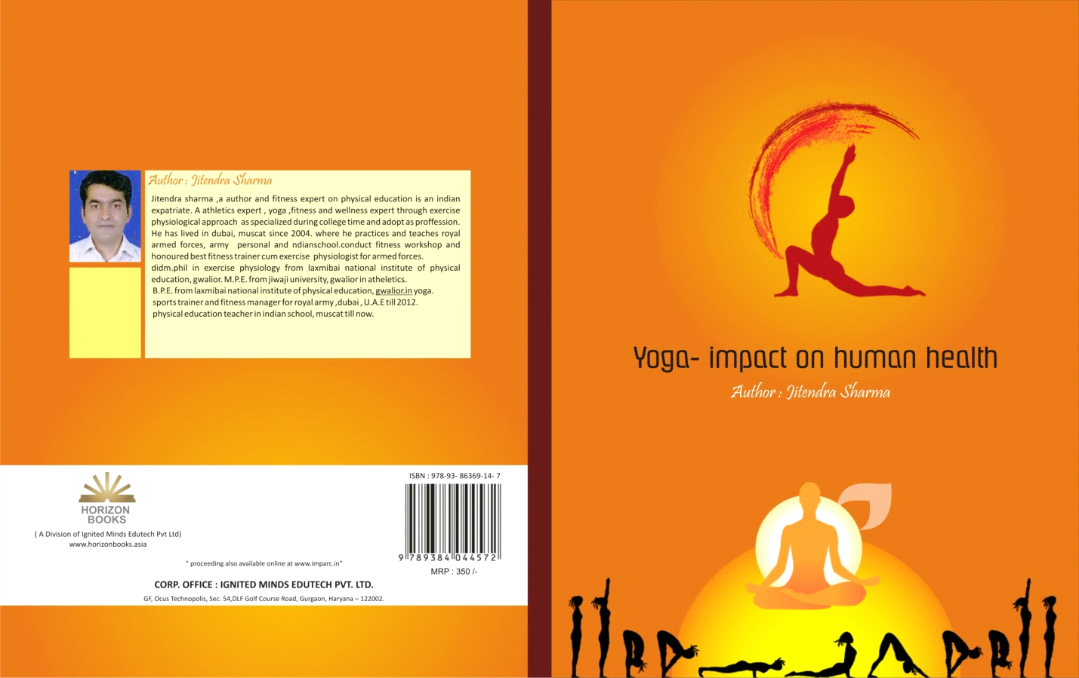

**3-** Applied Anatomy and physiology of yoga.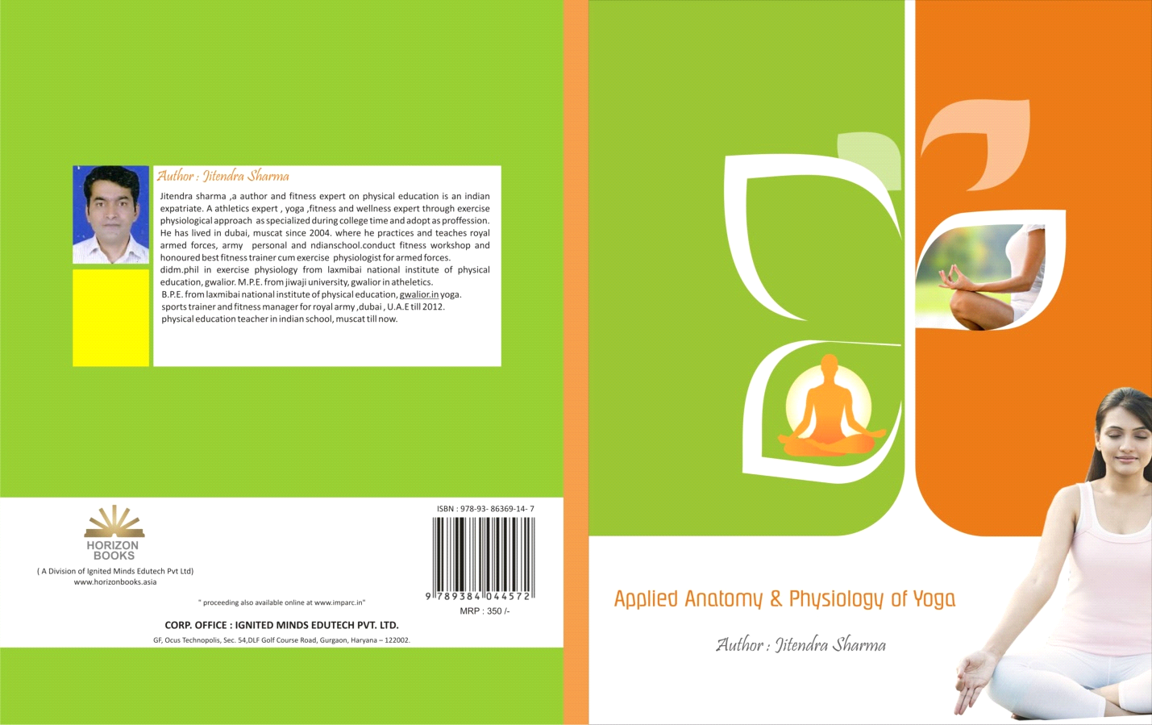

4-Complete Test and Measurement In physical education.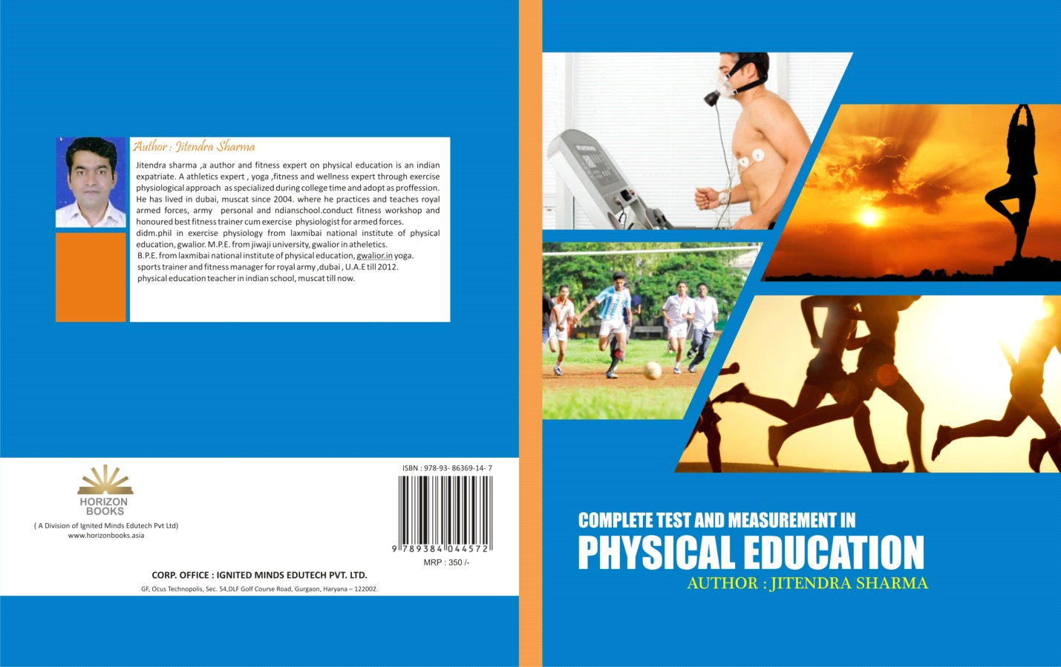

5-Health,Wellness, Fitness and Healthy life styles.

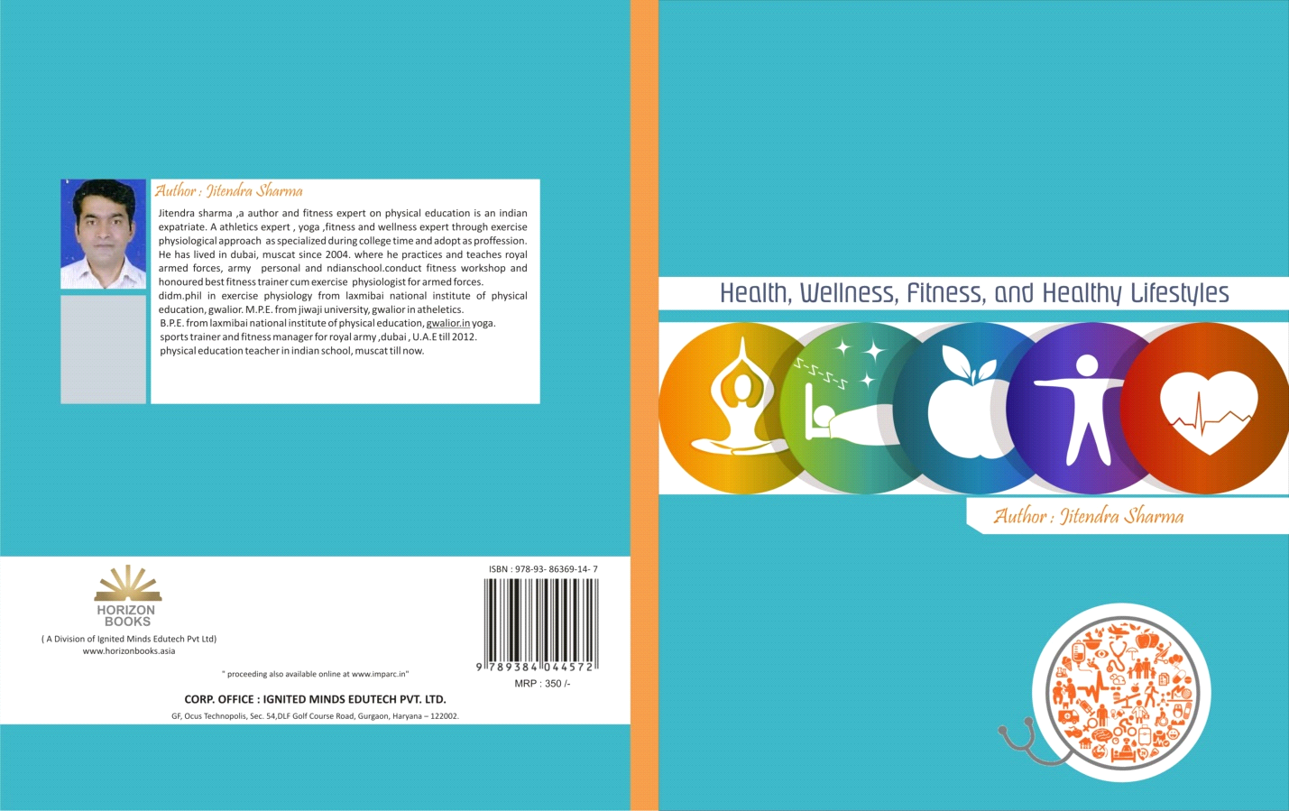

**LANGUAGE KNOWN:**

* **Hindi.**
* **English.**

**Date: 27-04-2022**

**Place: GWALIOR**

**(JITENDRA SHARMA)**